S.NO | Name | CAS NO | Structure
1 | Bivaracetam R,R isomer | 357337-00-9 | 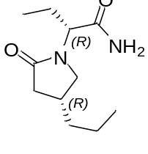
2 | Bivaracetam R,S isomer | 357336-99-3 | 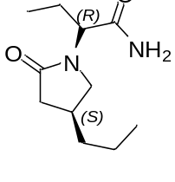
3 | Bivaracetam S,S isomer | 357336-19-7 | 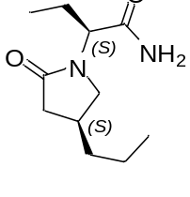
4 | Melphalan Impurity-G (Dimer) | NA | 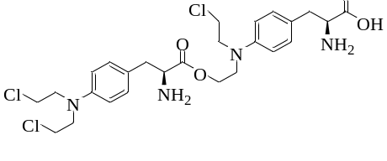
5 | Melphalan Impurity-J | NA | 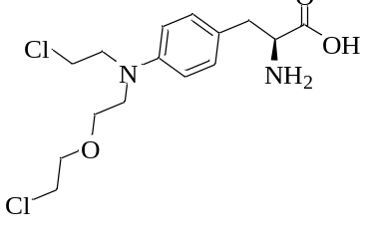
6 | Melphalan Impurity-I | NA | 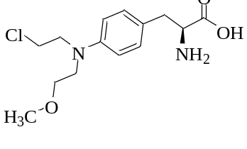
7 | Obeticholic Acid Impurity 3 | 1908444-28-9 | 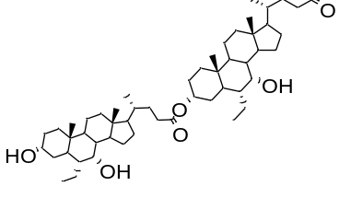
8 | Canagliflozin Dimer | NA | 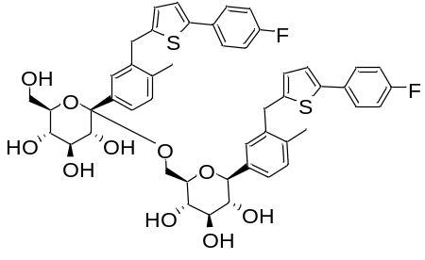
9 | Fluticasone 17-b-carboxylicacid | 28416-82-2 | 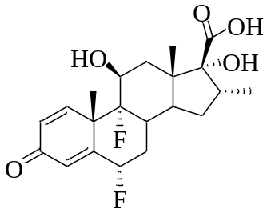
10 | Fluticasone Impurity 6 | 80474-67-5 | 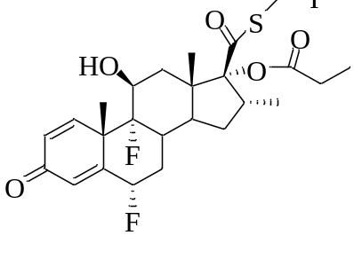
11 | Ibuprofen Impurity 7 | 69363-33-3 | 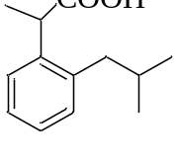
12 | Trimethoprim EP Impurity E | 60729-91-1 | 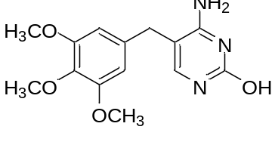
13 | Sucralose RS | 56038-13-2 | 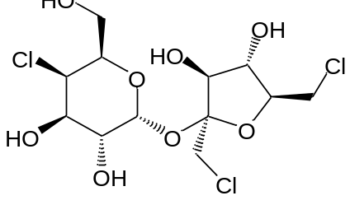
14 | Sucralose EP Impurity H | NA | 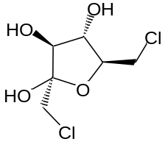
15 | Sucralose EP Impurity I | NA | 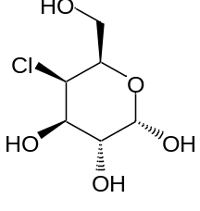
16 | Sucralose EP Impurity B | 40631-75-2 | 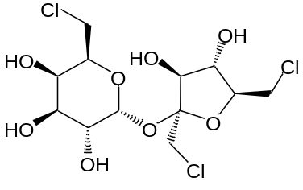
17 | DOXEPINE -Z ISOMER | NA | 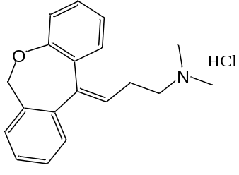
18 | Desmethyldoxepin | 2887-91-4 | 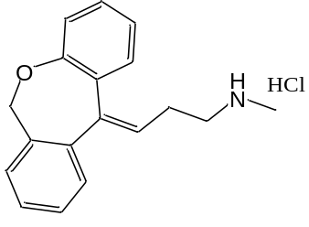
19 | Doxepin N-oxide | 22684-91-9 | 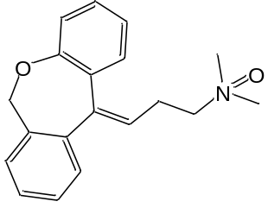
20 | OLOPATADINE HCl RS | 113806-05-6 | 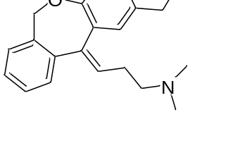
21 | Thiocolchicoside EP Impurity E | 219547-29-2 | 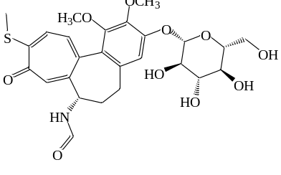
22 | Thiocolchicoside RS | 602-41-5 | 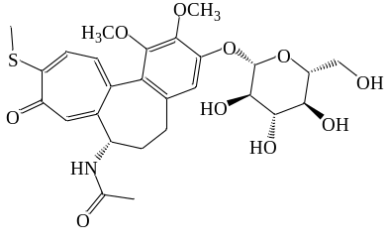
23 | Colchicoside | 477-29-2 | 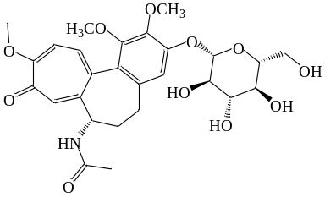
24 | Prasugrel Diketone impurity | 1391054 -37 -7 | 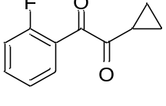
25 | Prasugrel impurity - 4 | 1373350 -61 -8 | 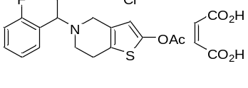
26 | Prasugrel impurity - IV | 947502 -66 -1 | 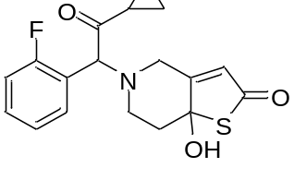
27 | 2,3 -Dichloro -4 -methylbenzoic acid | 1254073 -62 -5 | 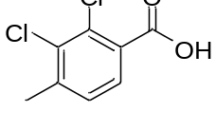
28 | 3,4 -Dichloro -2 -methylbenzoic acid | 5252 -99 -3 | 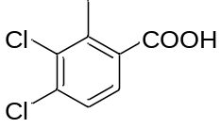
29 | 2,4 -Dichloro -5 -methylbenzoic acid | 6660-59-9 | 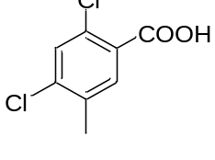
30 | 2,5 -Dichloro -4 -methylbenzoic acid | 21460-88-8 | 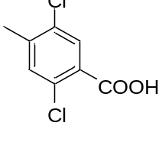
31 | Travoprost 13,14-Epoxide | NA | 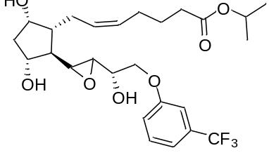
32 | 15-Keto Travoprost | 404830-45-1 | 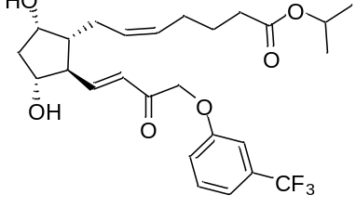
33 | Sumatriptan N-Oxide | 212069-94-8 | 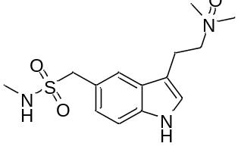
34 | Metamizole EP Impurity E | 117-38-4 | 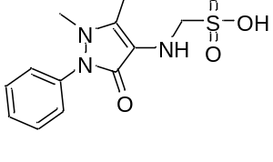
35 | (S)-Lansoprazole | 138530-95-7 | 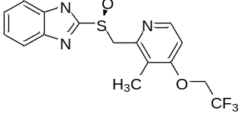
36 | 1,3,5-Benzene triamine | 108-72-5 | 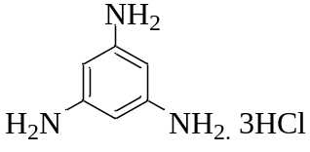
37 | 3-Oxo-7α-hydroxy-5β-cholanoic acid | 4185-00-6 | 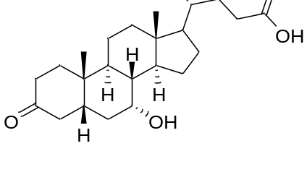
38 | Dapagliflozin C2 Epimer | 2133407-75-5 | 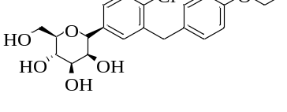
39 | Dapagliflozin 4-Bromo Analog | 1807632-95-6 | 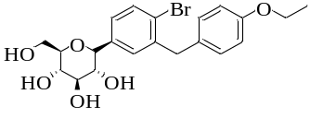
40 | (R)-4-propyldihydrofuran-2(3H)-one | NA | 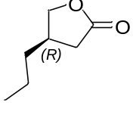
41 | (S)-4-propyldihydrofuran-2(3H)-one | NA | 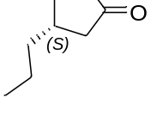
42 | 2,5-Dimethylundecane | 17301-22-3 | 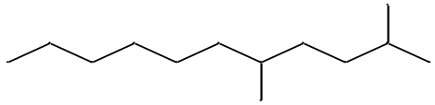
43 | 2,6,10-Trimethyltridecane | 3891-99-4 | 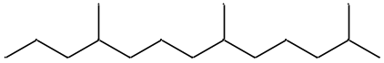
44 | 2-Methylundecane | 7045-71-8 | 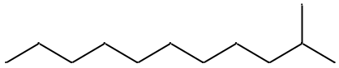
45 | 3-Methyl undecane | 1002-43-3 | 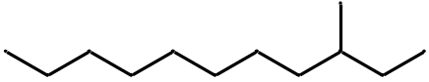
46 | 2,6,10-Trimethyldodecane | 3891-98-3 | 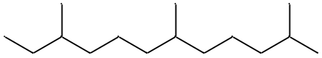
47 | Posaconazole Impurity 4 | 160709-02-4 | 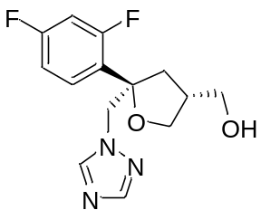
48 | Posaconazole Impurity 6 | NA | 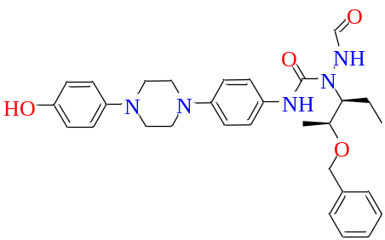
49 | Posaconazole Impurity 23 | NA | 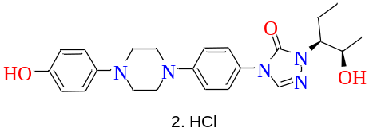
50 | Vildagliptin Impurity 5 | 96166-39-1 | 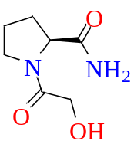
51 | N-Nitrosomethylethylamine  (NEMA) | 10595-95-6 | 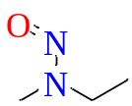
52 | N-Nitrosoisopropylethylamine  (NIEA) | 16339-04-01 | 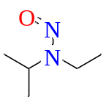
53 | N-NitrosodiIsopropylamine  (NDIA) | 601-77-4 | 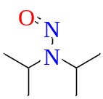
54 | N-Nitrosodimethylamine | 62-75-9 | 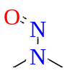
55 | N-Nitrosodiethylamine | 55-18-5 | 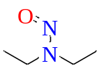
56 | N-isopropyl-N-methylnitrousamide | 30533-08-5 | 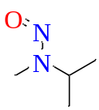
57 | 6-Chloro-7,9-dihydro-8H-Purin-8-one | 37527-48-3 | 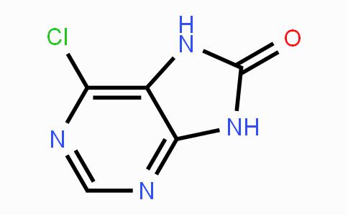
58 | Dehydro Carisoprodol | NA | 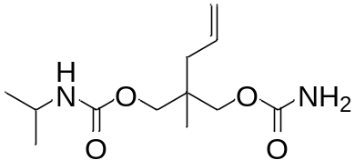
59 | Isopentyl Orlistat Tetradecyl Ester | NA | 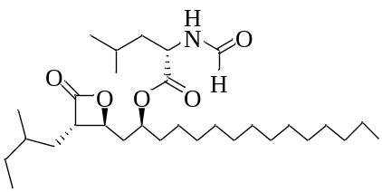
60 | 1-(4-aMinophenyl)-3-Morpholinopyridin-2(1H)-one | NA | 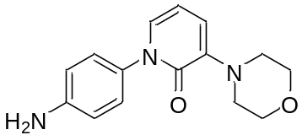
61 | Levofloxacin Impurity-3 | 106939-30-4 | 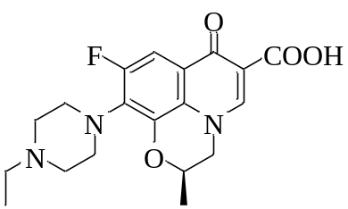
62 | Cetirizine Impurity- A | 303-26-4 | 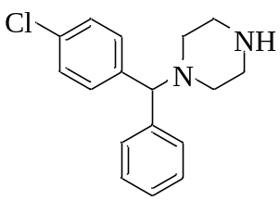
63 | Cetirizine Impurity- B | 113740-61-7 | 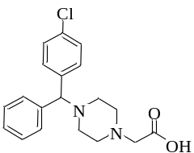
64 | Demethylbenztropine | NA | 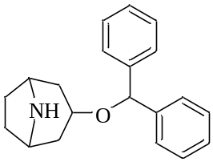
65 | Sodium Valproate EP Imp C | 62391-99-5 | 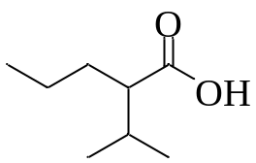
66 | Emapagliflozin R Furanose Impurity | 1620758-31-7 | 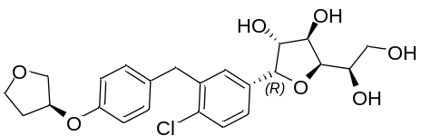
67 | 1-chloro-3-(dimethoxymethyl)benzene | 3395-80-0 | 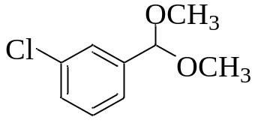
Rosuvastatin Impurities (EP)
68 | Rosuvastatin Calcium WS | 147098-20-2 | Ready stock
69 | Impurity-A (Acetone adduct) | 1714147-50-8 | Ready stock
70 | Impurity-B | 1094100-06-7 | Ready stock
71 | Impurity-C | 1620823-61-1 | Ready stock
72 | Impurity-D (Lactone) | 503610-43-3 | Ready stock
73 | Impurity-E (Hydroxy Dimer) | 2226413-0 (acid) | Ready stock
74 | Impurity -F (Tert butyl ester) | 289042-12-2 | Ready stock
75 | Impurity-G (Other isomer) | 1242184-42-4 (acid) | Ready stock
76 | Impurity -L (Di hydro impurity | 1024064-70-7 | Ready stock
77 | Impurity-K ( Dehydro impurity) | 1422954-12-8 | Ready stock
Sumatriptan Succinate
78 | Sumatriptan succinate WS |  | Ready stock
79 | Sumatriptan Related Compound A | 545338-89-4 | Ready stock
80 | Sumatriptan Impurity - B | 88919-51-1 | Ready stock
81 | Sumatriptan Impurity- C | 1797905-62-4 | Ready stock
82 | Sumatriptan Impurity- D | 212069-94-8 | Ready stock
83 | Sumatriptan Impurity- E | 88919-22-6 | Ready stock
84 | Sumatriptan Succinate Impurity F | 2074615-63-5 | Ready stock
85 | Sumatriptan Succinate Impurity G | 2074614-56-3 | Ready stock
86 | Sumatriptan Impurity H | 1391052-59-7 | Ready stock
Clopidogrel bisulfate
87 | Clopidogrel bisulfate | 113665-84-2 | Ready stock
88 | Clopidogrel Impurity -A (USP) | 144457-28-3 | Ready stock
89 | Clopidogrel Impurity -B (USP) | 144750-52-7 | Ready stock
90 | Clopidogrel Impurity -C(USP) | 120202-71-3 | Ready stock
91 | Clopidogrel Impurity -D (USP) | 1421283-60-4 | Ready stock
Ticagrelor
92 | Ticagrelor EP impurity A/IP impurity-B | 1251765-07-7 | Ready stock
93 | Ticagrelor IP impurity C | 2417326-48-6 | Ready stock
94 | Ticagrelor IP impurity D | 2417798-14-0 | Ready stock
95 | Ticagrelor EP impurity C/ IP Impurity-F | 1616703-93-5 | Ready stock
96 | Ticagrelor IP impurity G | NA | Ready stock
Montelukast Sodium
97 | Montelukast Sodium WS | 151767-02-1 | Ready stock
98 | Montelukast EP Impurity A (S)-Isomer | 190078-45-6(Na)  220927-27-5 (Acid) | Ready stock
99 | Montelukast EP Impurity B (Methyl Styrene imp) | 918972-54-0 | Ready stock
100 | Montelukast EP Impurity C (Sulfoxide Imp) | 909849-96-3 | Ready stock
101 | Montelukast EP Impurity D  Michael Adduct (R,R)-Isomer | 1187586-61-3 | Ready stock
102 | Montelukast EP Impurity E  Michael Adduct (R,S)-Isomer | 1187586-58-8 | Ready stock
103 | Montelukast EP Impurity F (Keto impurity) | 937275-23-5 | Ready stock
104 | Montelukast EP Impurity G (cis Isomer) | 774538-96-4 | Ready stock
105 | Montelukast EP Impurity H  Methoxycarbonyl Analog | 851755-56-1 (Base) ; 906107-37-7 (HCl) | Ready stock
106 | Montelukast EP Impurity I  Montelukast alpha-Hydroxy Analog | 2045402-27-3 | Ready stock
107 | Montelukast Amide impurity | 866923-63-9 | Ready stock
108 | Mont Acid | 158966-92-8 | Ready stock
109 | Montelukast DCHA salt | 577953-88-9 | Ready stock
110 | QUID-8 Isomer | 287930-77-2 | Ready stock
111 | MEC-6 Dimer Imp |  | Ready stock

